Docker Task
Task Description:
Install docker on EC2 and explore the docker commands (docker images, containers, volumes, network)
Install docker on EC2 server:
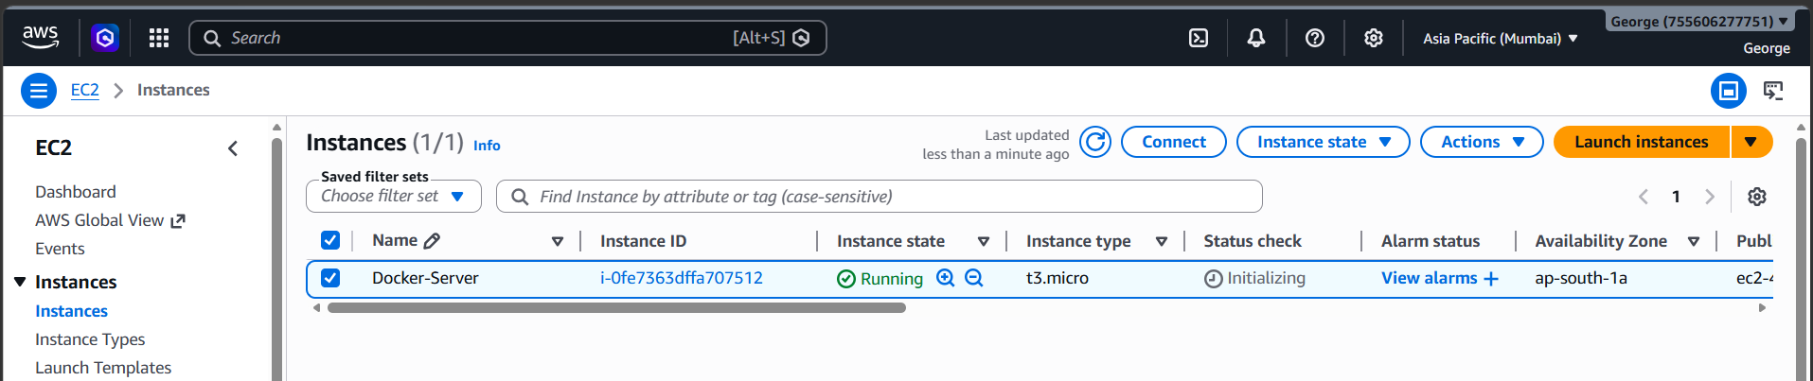
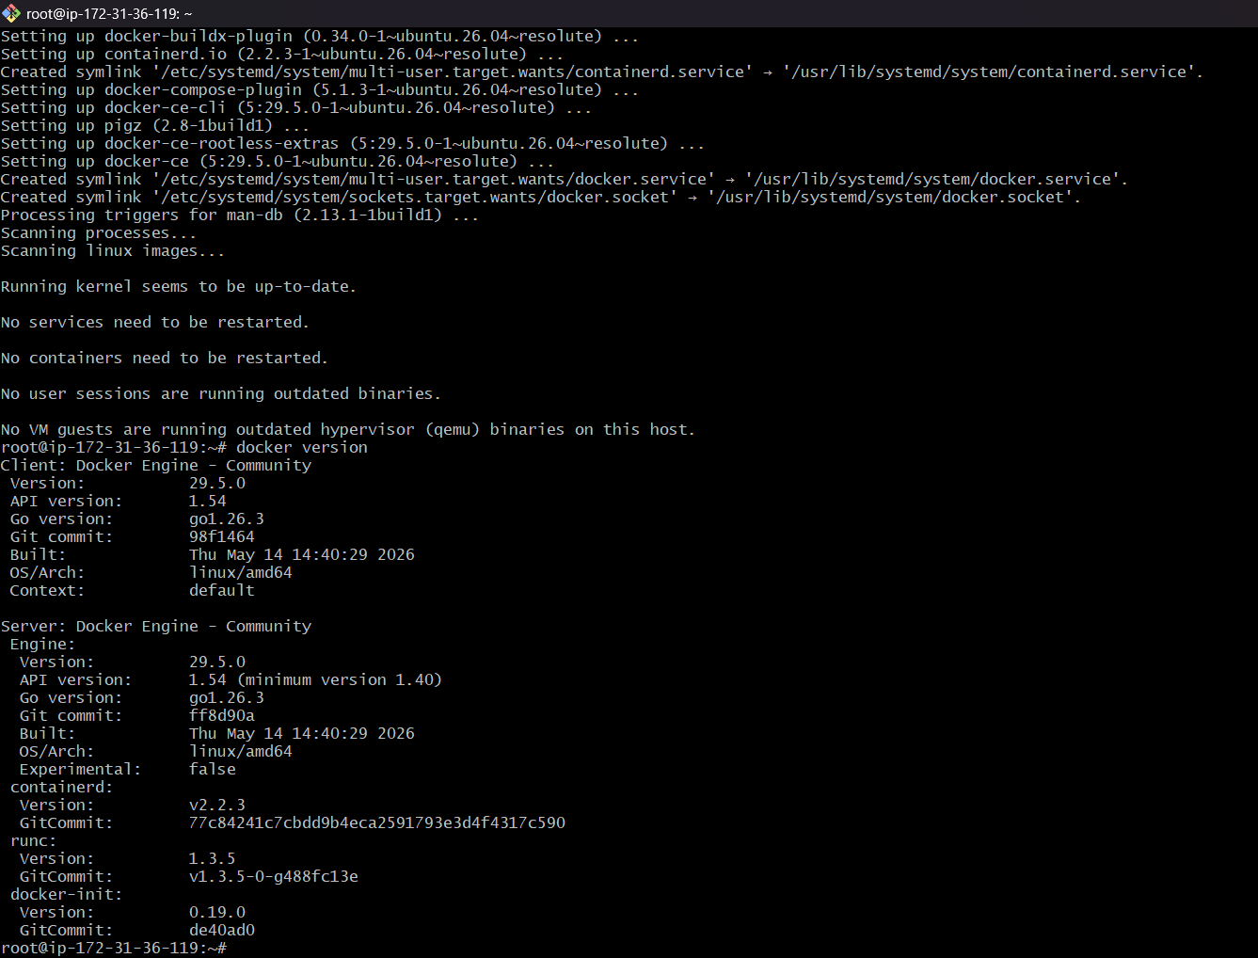

Explore the docker commands (docker images, containers, volumes, network)
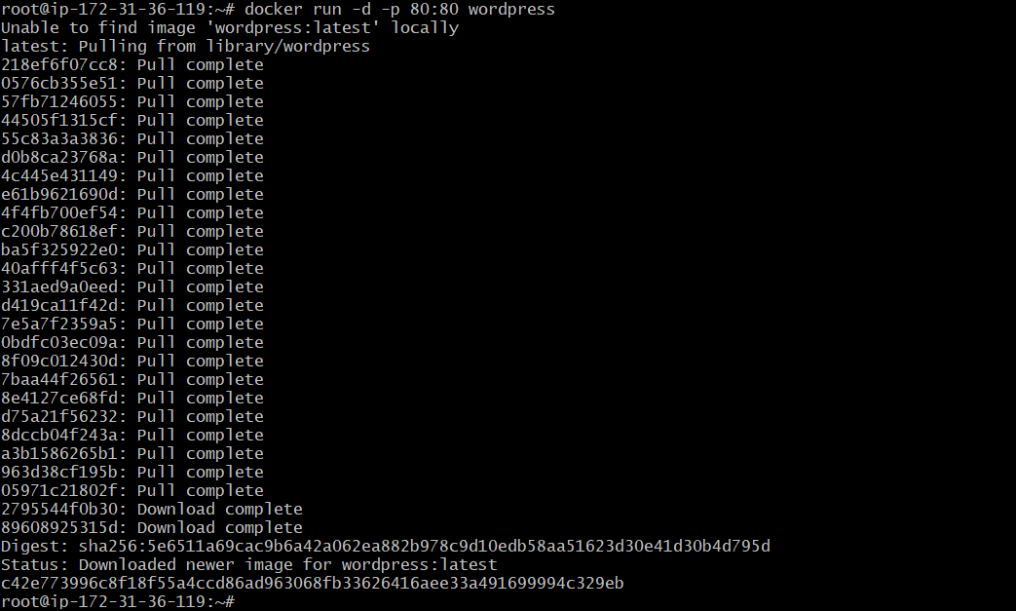
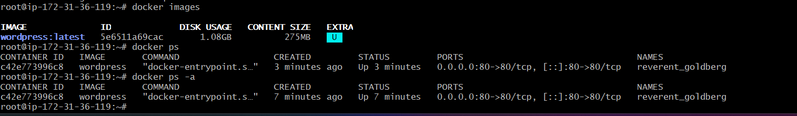
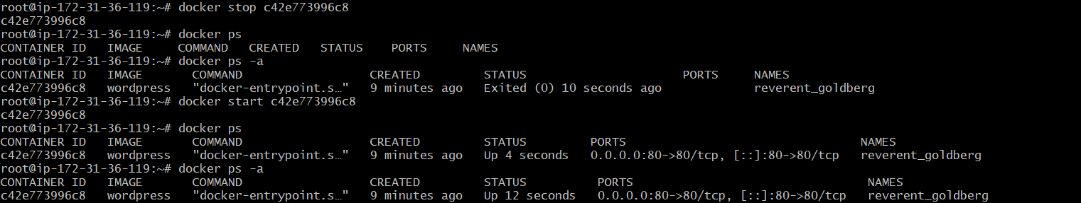
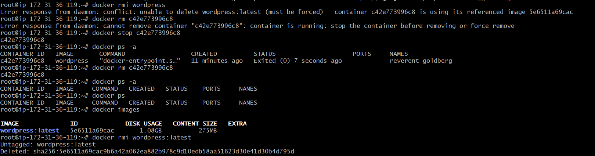

Volumes Operations:
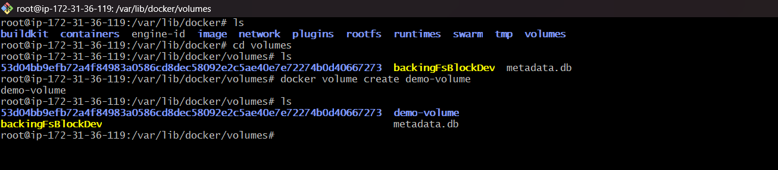
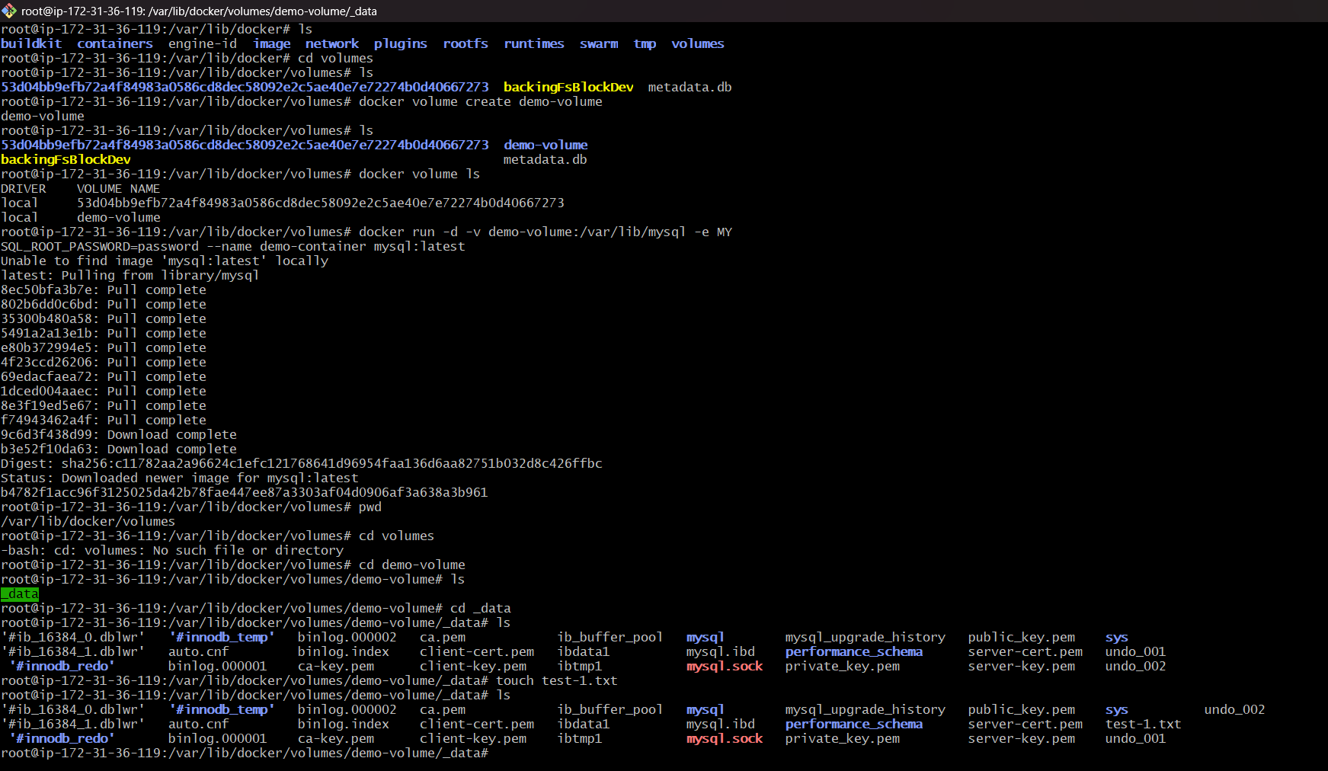
Login to the container to check the static data is available on both location:
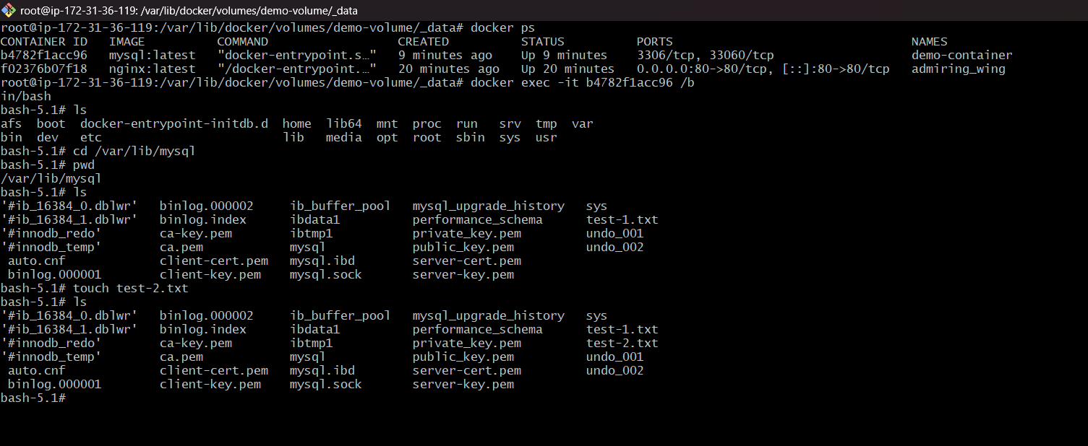

Remove the container and check the static data is available on created volume location:
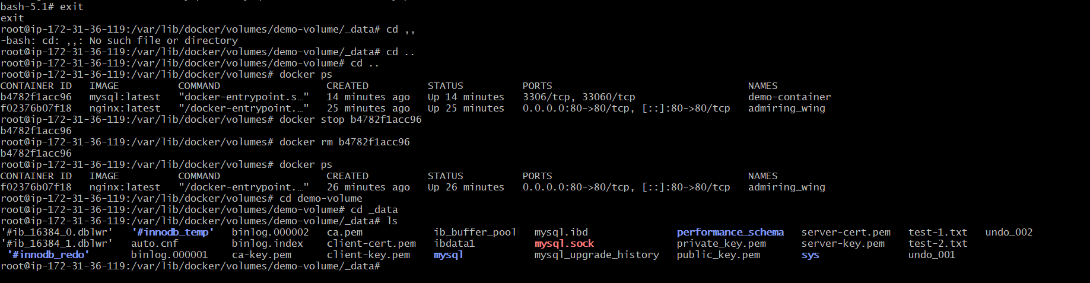
Network Operations:
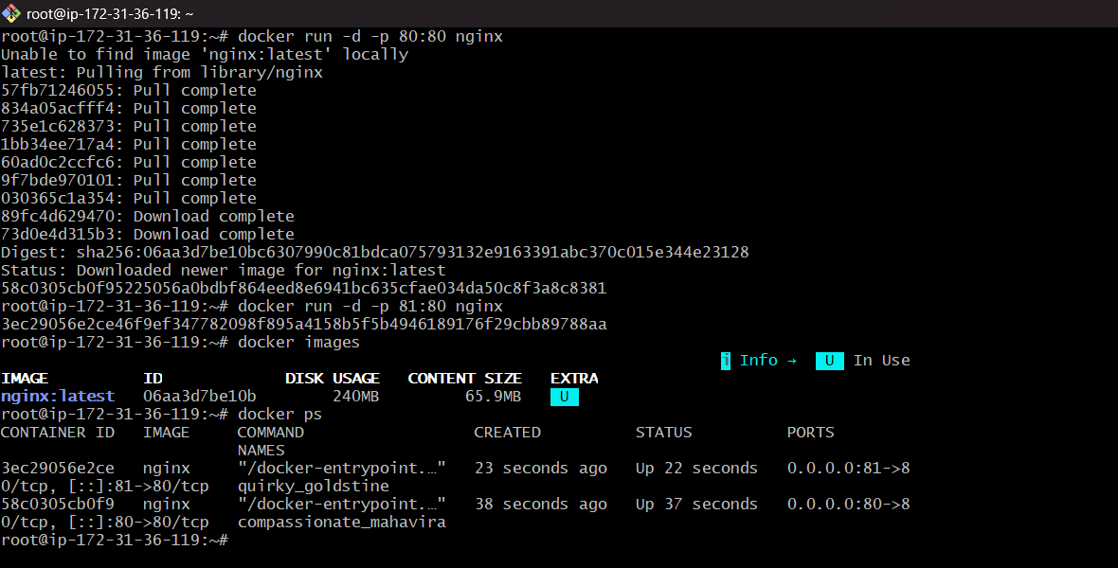

First container IP details:
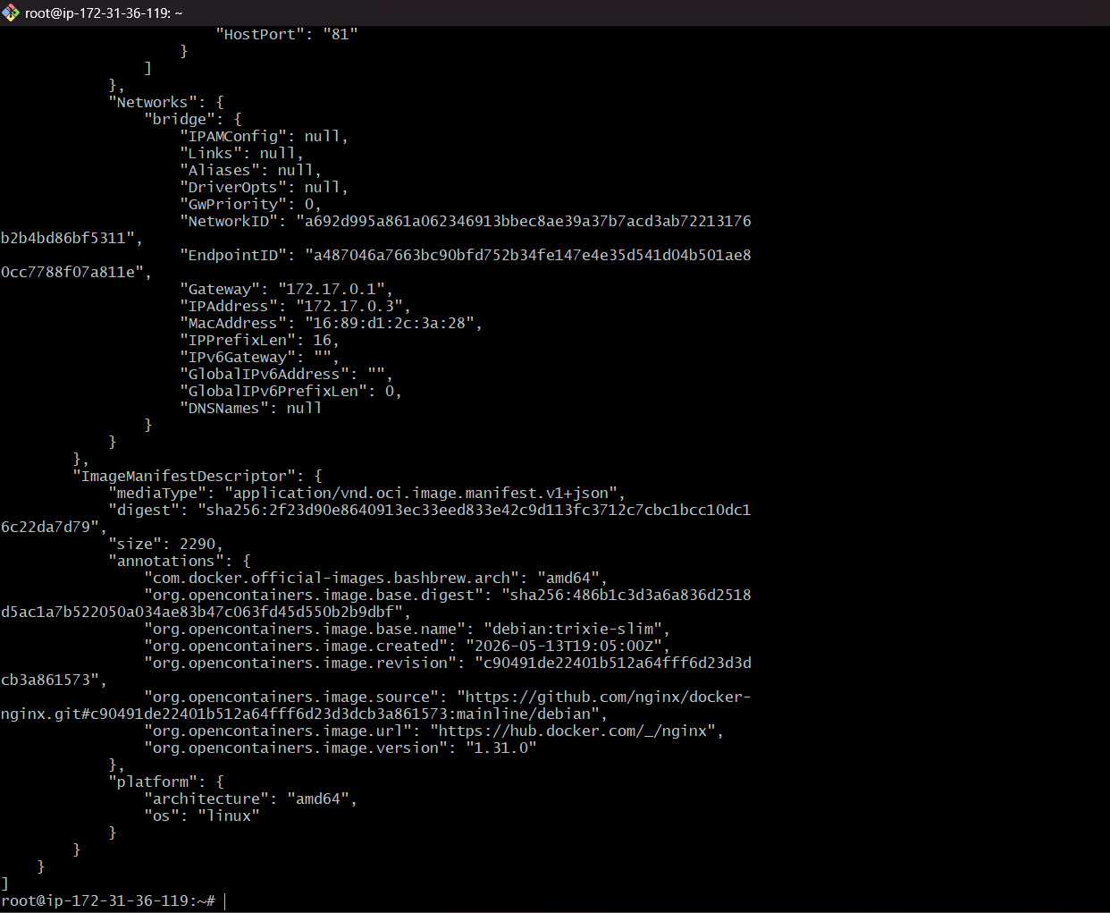
Second container IP details:
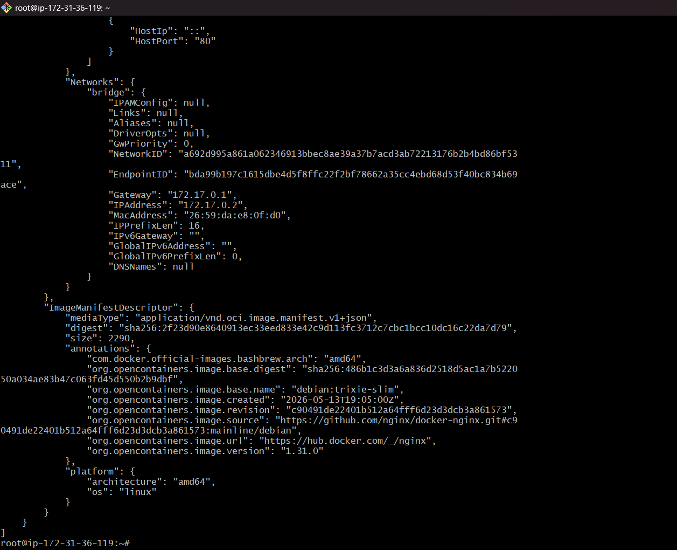

Both containers are communicating each other as successfully.
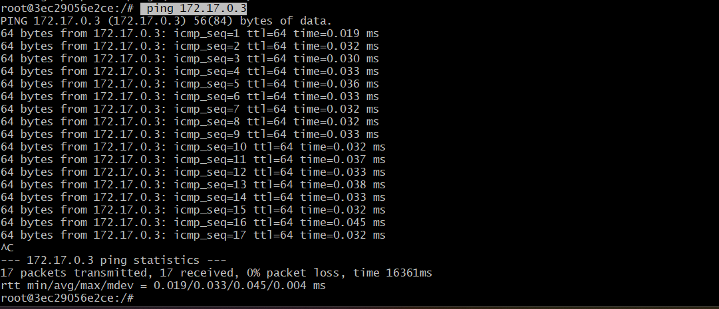
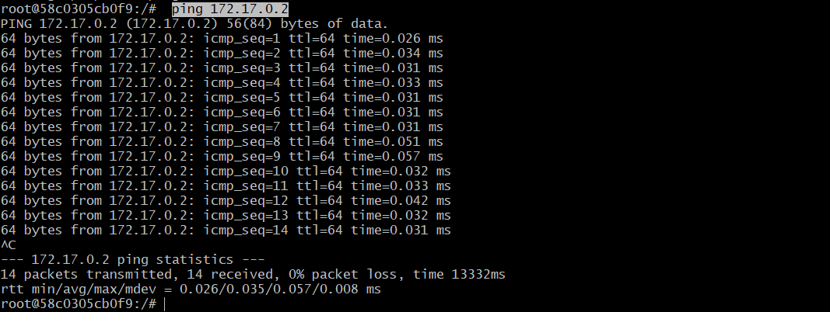
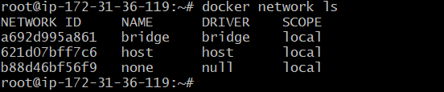
Create our own network:
